INSTITUTE OF ECONOMIC STUDIES
Faculty of social sciences of Charles University

Option Contracts
Lecturer’s Notes No. 2

Course: Financial Market Instruments I
Teacher: Oldřich Dědek
VII. BASIC FEATURES OF OPTION CONTRACTS

7.1 Call and put options
an option’s buyer (holder) has the right but not the obligation to buy (call option) or to sell (put option) an underlying asset at a fixed price (exercise price, strike price) at or before a specific date (maturity date, expiry date)
an option’s seller (writer) has the obligation to sell (call option) or to buy (put option) an underlying asset at a fixed price at or before a specific date if the option has been exercised by the holder
option premium (price of the option) is the amount the option’s buyer pays to the option’s seller in return for receiving the option

European option is the option that can be exercised only on the expiry date
American option is the option that can be exercise at any time before the expiry date

♦
An investor bought a call option written on 100 shares of the ABC with an exercise price of 140 € at a price of 5 €. The option expires in 2 months. The ABC shares are currently trading at 138 € per share. The investor thus paid a total option premium of 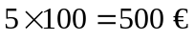.
a) at expiration the share price is trading at 155
⇨ the holder will exercise the option because the option gives him the right to buy the ABC share at 140 when the market price is 155 (the writer has the obligation to sell the share at 140)
net gain for the holder = 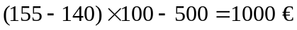
net loss for the writer = 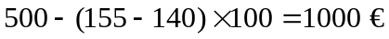
b) at expiration the share price is trading at 135
⇨ the holder will not exercise the option because the option gives him the right to buy the ABC share at 140 when the market price is only 135
net loss for the holder = 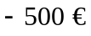
net gain for the writer = 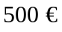
♦
An investor bought a put option written on 100 shares of the XYZ with an exercise price of 90 € at a price of 7 €. The option expires in 2 months. The XYZ shares are currently trading at 86 € per share. The investor thus paid a total option premium of 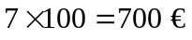.
a) at expiration the share price is trading at 65
⇨ the holder will exercise the option because the option gives him the right to sell the ABC share at 90 when the market price is 65 (the writer has the obligation to buy the share at 90)
net gain for the holder = 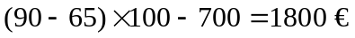
net loss for the writer = 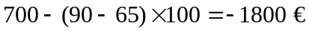
b) at expiration the share price is trading at 95
⇨ the holder will not exercise the option because the option gives him the right to sell the XYZ share at 90 when the market price is 95
net loss for the holder = 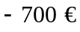
net gain for the writer = 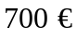
♦

7.2 Profit and loss profiles (P/L)
C … option premium of call option
P … option premium of put option
X … exercise price of the option’s underlying asset
S … current market price of the underlying asset
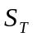 .. market price of the underlying asset at expiration of the option contract

profit and loss profiles at expiry of options
pay-off to holder of a call (long call) = 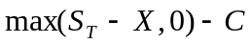
pay-off to writer of a call (short call) =
pay-off to holder of a put (long put) = 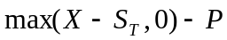
pay-off to writer of a put (short put) =

concise notation:
pay-off to the holder of an option =
pay-off to the writer of an option =

Profit and loss profiles at expiration of option contracts
Long call Short call
X
S_{T}
-C
X
S_{T}
C

Long put Short put
X
S_{T}
P
X
S_{T}
-P

decomposition of the option premium
option premium = intrinsic value + time value

intrinsic value is the value of the option if it were exercised immediately
intrinsic value of call option = 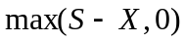
intrinsic value of put option =
in-the-money option is the option which is currently trading above the exercise price (the option has some intrinsic value)
at-the-money option is the option which is currently trading at the exercise price (the option’s intrinsic value is zero)
out-of-the-money option is the option which is currently trading below the exercise price (the option’s intrinsic value is zero)

time value is the part of the option’s premium that reflects the possibility of futures favourable movements in the price of the underlying asset (current out-of-the-money options may become at expiration in-the-money options and current in-the-money options may acquire at expiration even larger intrinsic value)
time value declines over time and vanishes at expiration

♦
The price of a call option with two months to maturity is 3$ when the stock price is 30$ and the exercise rice is 28$. Then the intrinsic value is 30-28 = 2$ and the time value is 3-2 = 1$. If the stock price were instead 26$ then the intrinsic value would be 0$ and the time value 3$.
♦

Short-run profit and loss profiles of option contracts
-C
A
Long call Long put
X
-P
A
B
C

B
S_{T}
X
S_{T}
S
C

short-run P/L profile crosses the horizontal axis through the current price
option premium (AC) = intrinsic value (BC) + time value (AB)

regularities in option premiums

Exercise | Premium on call options |  |  | Premium on put options
price | June | September | December | June | September | December
105 | 12 | 22 | 31 | 4 | 11 | 15
115 | 9 | 17 | 22 | 8 | 16 | 20
125 | 3 | 4 | 5 | 21 | 26 | 30
actual market price S = 115
- for a given exercise price the option premiums become the greater the more time remains to the expiration of the option (the longer is the maturity of the option the larger is the time value of the option)
- for a given expiry date the call option premium becomes the smaller the larger is the exercise price of the option (the larger is the exercise price the smaller is the intrinsic value at expiry)
- for a given expiry date the put option premium becomes the larger the larger is the exercise price of the option (the larger is the exercise price the larger is the intrinsic value at expiry)

types of option contracts
exchange-traded options
- traded on regulated exchanges
- highly standardized contract specifications (underlying asset, traded quantities, expiry months)
- clearing house that registers and clears trades, administers a system of margining and marking to market, guarantees the physical delivery
over-the-counter options
- tailor-made contracts in terms of size, expiry dates and other specifications
- buyers and sellers deal directly with each other and not through an organised exchange
- reduced liquidity and increased risk of default
- no system of margining requirements

margining in option contracts
premium paid options … buyers of the option have to pay the full price of the option at purchase
premium margined options … buyers are margined and marked to market (typical for options on futures contracts)

VIII. EXAMPLES OF FINANCIAL OPTIONS CONTRACTS

8.1 Equity options (stock options)

Name of the contract | LIFFE equity options contracts
Unit of trading | One option usually equals rights over 1000 shares.
Delivery months | Three expiry cycles: i) 1,4,7,10; ii) 2,5,8,11; iii) 3,6,9,12. The three nearest expiry months from the cycle are available.
Exercise day | By 17:20 on any business day, extended to 18:00 on a last trading day.
Last trading day | Third Wednesday of the expiry month.
Settlement day | Six business days after the exercise/last trading day.
Quotation | Pence per share
Tick size | 0.5 pence per share
Tick value | £ 5
Exercise price intervals | Set according a fixed scale determined by the Exchange (different for different shares). Additional exercise prices will be introduced after the underlying share price exceeded the second highest or fallen below the second lowest available price.
Initial margin | Premium is payable in full by the buyer on the business day following a transaction.
Position limits | Applied on the number of contracts that an investor can hold (they are linked to the value of a company’s issued capital).

the holder of a traded option does not have the right to receive any dividends paid on the share during its life (unless the option is exercised and acquired before the ex-dividend day)
an American call option on a non-dividend-paying share will never be exercise before maturity because it would be better to sell the option than to exercise it

8.2 Stock index options
a wide range of stock indices serves as an underlying asset in stock index options
LIFFE: FTSE 100, FTSE Eurotop 100, FTSE Eurotop 300, MSCI Pan Euro cash index
Name of the contract | LIFFE FTSE 100 index option.
Exercise style | American.
Unit of trading | Value of £10 per index point.
Expiry months | June, December plus four nearest calendar months are always available for trading.
Exercise day | Any business day by 16:45, extended to 18:00 on the last trading day.
Last trading day | Third Wednesday of the expiry month.
Settlement day | First business day after the exercise or the last trading day.
Quotation | Index points.
Tick size | 0.5
Tick value | £ 5.00
Exercise price intervals | 50 or 100 index points. Additional exercise prices will be introduced after the underlying index has exceeded the second highest or fallen below the second lowest available exercise price.
Daily settlement price | FTSE 100 index value published at 16:30 rounded to the nearest half index point.
EDSP | An average of values of the FTSE 100 index taken every 15 seconds between 10:10 and 10:30, of the 81 measured values the highest 12 and the lowest 12 will be discarded.
Initial margin | Premium is payable in full by the buyer on the business day following a transaction.

FLEX option = European-style option whose expiry date can be any business day within two years from the date the contract is made; any exercise price can be chosen, not simply those established by the exchange

♦
An individual buys one FTSE 100 June 5800 call option at a premium of 30 (he has the right between now and the June’s expiry date to buy the index at a level of 5800).
cost of call = 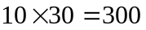£
If the option is exercised, the buyer receives from the writer the difference between the spot price and the exercise price of the index multiplied by 10£.
Let the index is standing at 5870.
buyer receives = 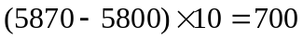£
total profit = 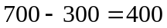 £
♦
triple witching hour
expression for the situation when stock index futures, stock index options and options on individual stock all expire on the same day
period of possible chaotic trading due to large offsetting positions in these contracts taken by traders

8.3 Currency options
a number of options are traded on specific currencies (sterling, Canadian dollar, Japanese yen, Swiss franc, Austrian dollar)
a contract is written on a specific size of traded currency (i.e. £ 12 500) in terms of US dollars
a long call option gives the holder the right to buy, for example, £ 12 500 for US dollars at a given exchange rate (exercise price) or equivalently to sell US dollars for obtaining a sterling equivalent of £ 12 500
⇨ a long sterling call option is equivalent to a long dollar put option

currency options in monetary policy
- testing credibility of a fluctuation band (for a credible band, options written for exercise prices outside the band should not be quoted at all or their premiums should be small)
- tests of likelihood of currency turbulences (expected increase in the exchange rate volatility should be reflected in an increase of option prices)

8.4 Options on interest rate futures contracts
the buyer of a call option on futures contract has the right to open one long position in the underlying futures contract and to be paid the difference between the actual futures price and the exercise price
the buyer of a put option on futures contract has the right to open one short position in the underlying futures contract and to be paid the difference between the actual futures price and the exercise price

Name of the contract | LIFFE option on three-month sterling (short sterling) interest rate futures contract.
Unit of trading | One three-month sterling futures contract.
Delivery months | March, June, September, December, such that six expiry months are available for trading.
Delivery day | The first business day after the exercise day.
Exercise day | By 17:00 on any business day prior to the last expiry/trading day and until 11:45 on the last trading day.
Last trading day | 11:00, last trading day of the three-month sterling futures contract.
Price unit | One basis point (0.01)
Tick size | 0.01 (for price unit value larger than 3 price units).  0.005 (for price unit value smaller than 3 price units).
Tick value | £ 12.5 (for price unit value larger than 3 price units, 500000×0.0001×¼).  £ 6.25 (for price unit value smaller than 3 price units).
Exercise price intervals | 0.25 or 0.125 when the contract is the front month quarterly delivery month.
Option price | As with futures positions the option positions are marked to market.

♦
An investor is holding a call option on the December short sterling (three-month) futures contract with an exercise price of 90.00 (implying a three-month interest rate of 10 percent). He paid the premium of 0.70 (70 ticks).
cost of call = 70 ticks × 12.5 = 875 £
The buyer of the call has the right to buy between now and December short-term futures at 90.00. Suppose that the price of the December contract rises to 91.50. If the buyer exercises the call his margin account is credited with a positive cash flow.
gain = (9150 – 9000) × 12.5 = 1875 £
net profit = 1875 – 875 = 1000 £
♦

some other option-typed instruments
stock in a levered firm can be seen as a call option provided by the firm’s debtholders to the firm’s shareholders
warrant is an option issued by a firm to purchase a given number of shares in that firm at a given exercise price at any time before the warrant expires
swaption is an option written on a swap contract
callable bond allows its issuer to redeem the bond before maturity at a specified price
embedded options are option features that make a part of some financial instruments (i.e. prepayment of mortgage, time deposit with a possibility of earlier withdrawal, shares in a levered firm, etc.)
IX. OPTION COMBINATIONS
a variety of new profit and loss profiles can be created by combining four basic option types: long call, short call, long put, short put
classification:
i) combinations involving either all long options or all short options (combinations)
ii) combinations involving mixtures of long and short options (spreads)
iii) combinations involving an option and the underlying asset
synthetic security (proxy) is a security constructed from combinations of two of more basic securities in the process knows as financial engineering
basic securities: call and put option, share and riskless bond
profit and loss profile for a share (with respect to the initial purchase of sale price X)
upward-sloping line if the share was purchased
downward sloping line if the share was sold short
profit and loss profile for a bond
horizontal line independent of the share price
long bond is equivalent to lending and short bond is equivalent to borrowing

Profit and loss profiles of basic securities
S
X
short share
long share
S
short bond
long bond

9.1 Combinations

combinations involve either all long or all short option positions
a) straddle is the combination of a call option and a put option on the same security, with the same exercise price and the same expiry date
long straddle = long call & long put
short straddle = short call & short put

Profit and loss profile of a long straddle
long call
long put
X
S
long straddle

buyer of a straddle is expecting a big jump in share prices but is not sure of the direction (he makes a profit if the underlying moves far enough in either direction in return for paying two premiums)
seller of a straddle is expecting little or no change in share prices (he benefits if volatility is low)

b) strangle is the combination of a call option and a put option on the same security, with the same expiry date but different exercise prices
long strangle = long call with a higher exercise price & long put with a lower exercise price
short strangle is a mirror image of the long strangle

Profit and loss profile of a long strangle
long strangle
long call
long put
X₁
X₂

buyer of a strangle is betting on a substantial price change but is not certain whether it will be an increase or a decrease (similar to straddle); option premiums are likely to be reduced by setting exercise prices apart (call is cheaper for a higher exercise price) but profit is generated only if the underlying share price moves significantly
seller of a strangle benefits form an extended range of share price movements over which the position will continue to make a profit

c) strap is the combinations of two call options and one put option (all long or all short) on the same security, with the same exercise price and the same expiry date
long strap is similar to a long straddle but with a steeper right arm as a result of using two calls rather than one
strap can involve option combinations with different exercise prices giving the payoff similar to that of a strangle (with a steeper right arm)

d) strip is the combinations of one call option and two put options (all long or all short) on the same security, with the same exercise price and the same expiry date
long strip is similar to a long straddle but with a steeper left arm as a result of using two puts rather than one
strap can involve option combinations with different exercise prices giving the payoff similar to that of a strangle (with a steeper right arm)

Profit and loss profile of a long strap
1 long call
long put
X
S
long strap
2 long calls

9.2 Spreads
spreads involve mixtures of long and short option positions
classification of spreads
vertical (cylinder) spreads are combinations of options with the same expiry date but different exercise prices
horizontal (calendar) spreads are combinations of options with the same exercise price but different expiry dates
diagonal spreads are combinations of options with different exercise prices and different expiry dates
butterfly spreads are combinations of two spreads

terminology
buying a spread (long spread) means buying a more expensive option and selling a cheaper option
selling a spread (short spread) means selling more expensive option and buying a cheaper option

e1) vertical bull call spread is the combination with a long call with a low exercise price and a short call with a high exercise price
e2) vertical bull put spread is the combination with a long put call with a low exercise price and a short put with a high exercise price

Long vertical bull call spread Short vertical bull put spread
X₂
X₁
long call
short call
X₂
X₁
long put
short put

both types of vertical spreads give rise to similar profit and loss profiles: a bullish middle segment, limited losses if the underlying price falls but limited gains if the underlying price rises
purchase of an option with a low exercise price is partially offset by the simultaneous sale of an option with a high exercise price that limits the potential gain if the underlying price goes up

f1) vertical bear call spread is the combination of a short call with a low exercise price and a long call with a high exercise price
f2) vertical bear put spread is the combination of a short put with a low exercise price and a long put with a high exercise price

Short vertical bear call spread Long vertical bear put spread
X₂
X₁
long put
short put
X₁
long call
X₂
short call

both types of vertical spreads give rise to similar profit and loss profiles: a bearish middle segment, limited losses if the underlying price rises but also gains if the underlying price falls

g1) rotated vertical bull spread is the combination of a short put with a low exercise price and a long call with a high exercise price
g2) rotated vertical bear spread is the combination of a long put with a low exercise price and a short call with a high exercise price

Rotated vertical bull spread Rotated vertical bear spread
X₁
X₂
short put
long call
X₁
short call
long put
X₂

rotated vertical spreads are designed to profit from a zone of ignorance in an otherwise bullish or bearish market
they generate an initial income accruing from the sale of more expensive options

h) synthetic futures is the combination of options that reproduces the profit and loss profile of a futures contract (rotated vertical spread with one exercise price)

Long synthetic futures Short synthetic futures
X
short put
long call
long put
X
short call

i1) horizontal call spread is the combination of a short (i.e. sold) short-maturity call option and a long (i.e. purchased) long-maturity call option when both options have the same exercise price
i2) horizontal put spread is the combination of a short short-maturity put option and a long long-maturity call option (both options have the same exercise price)

profit and loss profiles of horizontal options show the pay-off when the short-maturity option expires and long maturity option is sold at that time
earlier maturing option has only intrinsic value while later maturing option has also time value

Profit and loss profile of a horizontal call spread
long later-maturing call
short earlier-maturing call
X

the horizontal spread makes a profit if the underlying price at expiration of the short-maturity option is close to the exercise price
a loss is incurred when the underlying price is significantly above or significantly below the exercise price

j1) butterfly call spread is the combination of a long call with a low exercise price, two short calls with a middle exercise price and a long call with a high exercise price
alternative definition: long vertical bull call spread with low and middle exercise prices & short vertical bear call spread with middle and high exercise prices
j2) butterfly put spread is the combination of a long put with a low exercise price, two short puts with a middle exercise price and a long put with a high exercise price
alternative definition: long vertical bull put spread with low and middle exercise prices & short vertical bear put spread with middle and high exercise prices

Profit and loss profile of a butterfly call spread
short vertical bear call spread
long vertical bull call spread
X₃
X₂
X₁

position makes a profit if the underlying price stays close to the middle exercise price and gives a loss if there is a significant underlying price move in either direction
a large number of very small spikes can approximate any payoff function

k) condor is the combination of a long call (or put) with a low exercise price, two short calls (or puts) with different middle exercise prices and a long call (or put) with a high exercise price

Profit and loss profile of a condor
X₄
X₃
X₂
X₁

9.1 Combinations involving an option and the underlying asset

l) covered call arises when the writer of a call option (short call) has an offsetting position in the underlying security (long underlying)
combination of a short call and a long underlying (usually it is a share) gives the payoff of a short put (synthetic short put)
without an offsetting position in the underlying asset the call option is said to be naked

Profit and loss profile of an at-the-money covered call

covered call = synthetic short put
X
long stock
short call

at-the-money call means that the purchasing price of a share is equal to the underlying price of a call option
manager of a stock portfolio may raise additional income in otherwise flat or bearish market by receiving option premium at cost of giving up an unlimited upside potential
writer of a call option wants to be protected against potential unexpected loss occurring from exercising the option (otherwise he would have to purchase the stock at a high market price when the option is exercised)

m) protective put arises when the underlying asset (long underlying) is supplemented with buying put option written on the underlying (long put)
combination of a long underlying (usually it is a share) and a long put gives the payoff of a long call option (synthetic long call)

Profit and loss profile of an at-the-money protective put
protective put = synthetic long call
X
long stock
long put

protective put provides portfolio insurance (some upside potential is lost but portfolio is protected against unlimited loss in case of unfavourable development of prices)
X. FAIR PRICING OF OPTIONS CONTRACTS

fair price is the theoretical price that would be observed in perfectly competitive markets in the absence of arbitrage opportunities

10.1 The binomial model
the simplest model for determining the price of an option
the simplest type of option is the European call option on a security that makes no cash payments (e.g. a non-dividend-paying share)
the security price follows a stationary binomial stochastic process (at the end of the period it can be higher or lower that at the start of the period by a fixed multiplicative jumps)
C ...price of a call option (to be determined)
S ... price of the underlying share (= 500$)
X ... exercise price (= 450$)
q ... probability that security price will rise (= 50 %) ⇨ 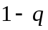 is the probability that security price will fall
u ... multiplicative upward movement in security price (= 1.3)
d ... multiplicative downward movement in security price (= 0.7)
r ... risk-free interest rate (= 10 %)

Binomial tree of price movements of an underlying share
u²S
(845)
udS
(455)
d²S
(245)
q
q
S
(500)
uS
(650)
dS
(350)
q
1-q
1-q
1-q

One-period binomial tree of expiry values of a call option
C
C_{u} = max [0, uS - X]
(200)
q
1-q
C_{d} = max [0, dS - X]
(0)

delta-neutral portfolio (delta-neutral covered call) is a combination of a long position in the underlying share and a short position in h units of the call option such that the value of the portfolio is always the same regardless of whether the underlying price goes up or down
h is the hedged ratio defined as a number of call options to be written against the underlying security
a) terminal value of the delta-neutral portfolio is given by
share price rises ⇨ 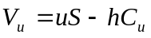
share price falls ⇨ 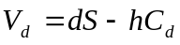
delta-neutral portfolio must have the same terminal value in all states
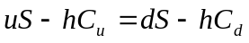
the equation can be solved for the hedged ratio h
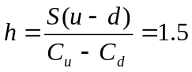
and the terminal value of the delta-neutral portfolio is always
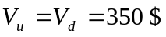

b) delta-neutral portfolio that has no risk must earn the risk-free interest rate (equivalently the current value of the delta-neutral portfolio can be determined by discounting the future value at the risk-free interest rate)
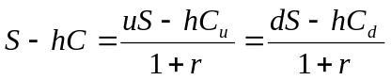
solving for the price of the call option results in the conclusion that the fair option premium is the discounted value of the expected expiry values of the option
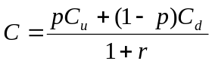, where 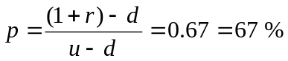
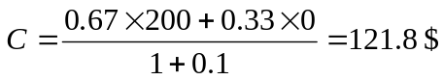
the variable p is called the hedging probability (it does not depend on the true probability q of the share price’s change)

c) hedging probability is consistent with the so-called risk-neutral environment
in risk-natural world the expected return on all securities is equal on average to the risk-free interest rate
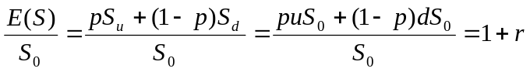
in the real world two things happen
- the expected growth rate of the underlying price may change (due to different probabilities applied to price changes)
- a different discount rate must be used for discounting the expected pay-off of the sucurity
these two changes may offset each other exactly therefore the risk-neutral valuation can be still used in the real world

general binomial model extended to n consecutive periods
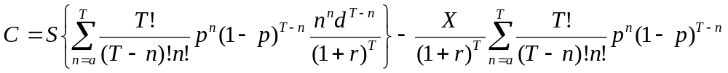
a ... exclusion of out-of-the-money states
30 steps ⇨ 31 terminal prices, about 1 billion possible price paths (2³⁰)

10.2 The Black-Scholes model
a major breakthrough in the pricing of options, huge influence on financial engineering
assumptions:
- the security price follows continuous-time random walk (geometric Brownian motion, diffusion process) in which future relative price changes are independent both of past changes and of the current price
- volatility and interest rates both remain constant throughout the life of the option (significant problems for option contracts involving bonds because volatility of bond prices tends toward zero as the bond approaches maturity and the bond price itself crucially depends on interest rates)
- probability distribution of relative price changes is lognormal (an implication is an understatement of probabilities of significant deviations from the mean)
derivation of the BS formula requires advanced techniques of mathematical calculus (solution of partial differential equation, infinitesimal extension of the binomial model)

Black-Scholes formula
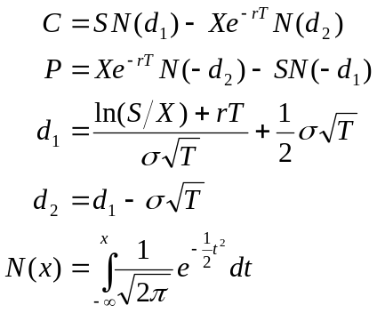
C … fair price of European call option
P … fair price of European put option
S … current price of underlying security
X … exercise price
r … risk-free interest rate
T … time to maturity of the option (in fractions of a year)
σ … instantaneous standard deviation (volatility) of underlying’s price changes (computed from log price relatives)
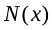 … cumulative probability distribution function for a standardized normal distribution

♦
Compute the price of a call option using the same data as for the binomial model, i.e. S = 500, X = 450 $, r = 10 %, T = 1, u = 1.3, d = 0.7, q = 0.5.
Estimation of the volatility:
expected log price relative
E = 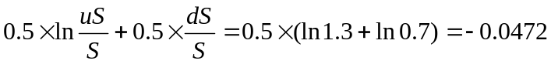
variance of log price relatives
VAR =
volatility of log price relives
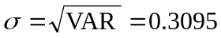
application of the B-S formula gives
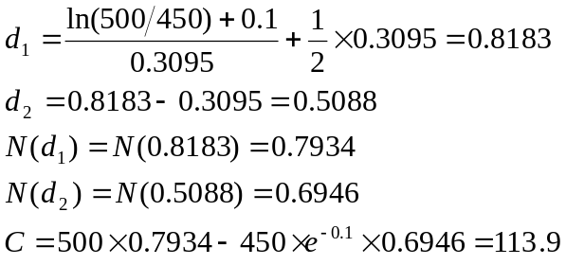
call premium according to the binomial model = 121.8 $
call premium according to the B-S model = 113.9 $
♦

all factors in the B-S formula are readily observable except for the volatility that must be estimated
estimation methods:
- using historical data on the security’s price movements and calculating the variance based on log price relatives 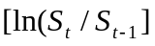
- computing implied volatility which is the solution for the standard deviation in the B-S formula given all other observable variables (option premium, particular exercise price, current security price, time to expiry and riskless interest rate)

extensions to the B-S model
a) European call option on a dividend-paying stock
stock price is the sum of two components
- riskless component = present value of all the dividends during the life of the option discounted from the ex-dividend date at the risk-free interest rate (amount and timing of the dividends can be predicted with certainty)
- risky component = remaining value of the stock price
B-S formula can be used provided that the present value of future dividends is subtracted from the current share price
♦
A share from the previous example is expected to pay a dividend of 6 $ in one month. The risky component of the share price is given by
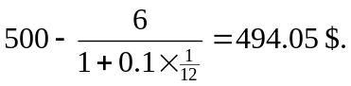
The share price of 494.05 should be substituted into the B-S formula.
♦
the same principle can be applied to the valuation of stock index options and currency options (with a predictable cash flow stemming from the underlying asset)

b) valuation of American options
the B-S formula can be used for pricing American call options on non-dividend-paying stock because these options should never be exercised early (the better alternative is to sell the option rather to exercise it)
no exact analytic formula has been produced for the value of an American put option on a non-dividend-paying stock
no exact analytic formula exists for the value of American call and put options written on a dividend-paying stock
some approximations have been suggested
the binomial model can be used where at each step it is necessary to check whether it is optimal to exercise the option just prior to an ex-dividend day or to hold on to the option for one more period

c) volatility smile is an analytical relationship between volatility of the underlying asset (as one of the inputs into the B-S formula) and the exercise price of the option
volatility smile is not consistent with the B-S formula where the volatility is the attribute of an underlying asset (therefore implied volatilities for all options written on a given security should be the same regardless of being puts or calls, regardless of the time to expiry)
volatility smile is a response of practitioners to unsatisfactory outcomes of the B-S model when it is applied to the valuation of deep in-the-money and deep out-of-the-money options (consequence of the lognormal distribution of price changes)

Volatility smiles for currency and stock options
currency option equity option
σ
σ

X
X

sources of smile:
currency options: the volatility is relatively low for at-the-money options (medium-level exercise prices) and it becomes progressively higher as the option moves either in the money or out of the money (high and low level exercise prices)
equity options: as a company’s equity declines/increases in value the company’s leverage increases/declines and as a result the volatility of its equity also increases/declines (stock in levered company can be seen as a call option with the debt being its exercise price)
volatility term structure means that the volatility used to price an option depends on the maturity of the option
if short-dated volatilities are historically low than volatility tends to be an increasing function of maturity (there is an expectation that volatilities will increase); similarly for long-dated volatilities
volatility surface combines volatility smile with volatility term structure in the valuation of options

 | Exercise price
Expiry | 0.90 | 0.95 | 1.00
1 month | 14.2 | 13.0 | 12.0
2 months | 14.0 | 13.0 | 12.0
3 months | 14.1 | 13.3 | 12.5

some of the entries correspond to options for which reliable market data are available; the rest of the table is determined using linear approximation

10.3 Sensitivity analysis
Greek letters (Greeks) measure particular sensitivities of the option premium to changes in the determining factors
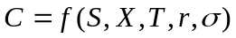
Greeks are extensively used in managing option portfolios (they show how the value of the option will vary with changes in various factors affecting their premiums)
the concept of Greek sensitivities can be applied to any security (i.e. option delta, portfolio delta, security delta, etc.)

a) option delta measures how the option value varies with changes in the underlying price
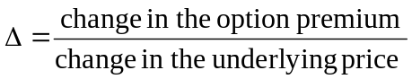
delta is the partial derivative of the option premium with respect to the underlying
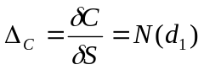, 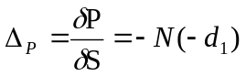
delta is used for the first-order approximation of the change in the option premium
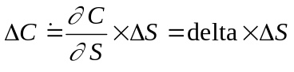
delta is a positive number for long calls and short puts and a negative number for short calls and long puts
delta is close to zero for deep out-of the-money options and close to zero for deep in-the money options
delta of an option portfolio is the weighted average of deltas of options from which the portfolio is composed

delta-hedging is a strategy that aims to create a delta-neutral portfolio in which the gain (loss) on the option position would tend to be offset by the loss (gain) on the underlying position (the portfolio delta is zero)
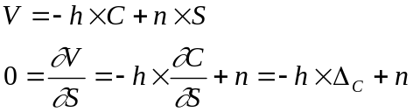
in a delta-hedged portfolio the hedge ratio h is equal to the inverse of the option delta
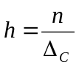 or 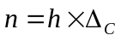
♦
A call option on a share has a delta of 0.7525. Given that a standard option contract is for 1000 shares than for delta-hedging of 1000 shares it is necessary to write
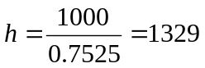 call options.
♦

dynamic delta-hedging consists in periodic adjustments in the hedged ratio with the aim to restore the delta-neutral position of the portfolio affected by changes in the underlying price that change the option delta

♦
A bank has written 100 000 call options and wants to be protected against changes in the option value by maintaining a delta-neutral position. The table shows the performance of a dynamic delta-hedging strategy with weekly rebalancing (interest rate costs are ignored).

Week | Share price | Delta | Change in stock | Cash flow
0 | 49.00 | 0.522 | +52200 | -2577800
1 | 48.12 | 0.458 | -6400 | +308000
2 | 47.37 | 0.400 | -5800 | +274700
3 | 50.25 | 0.596 | +19600 | -984900
4 | 51.75 | 0.693 | +9700 | -502000

At the beginning the bank purchases 100000×0.522 = 52200 shares and pays for them the market price 52200×49 = 2577800 $.
By the time of the first rebalancing the share price went down that resulted in a lower delta of the option. To restore the delta-neutral position the bank sells shares in the amount of 52200 - 100000×0.458 = 6400 and obtains an income of 6400×48.12 = 30800 $ (rounded to hundreds).
♦
for deep out-of-the-money options (with deltas close to zero) the outcome of the dynamic delta-hedging strategy is a naked option
for deep in-the-money options (with deltas close to one) the outcome of the dynamic delta-hedging strategy is a covered option

b) option gamma (curvature of the option) measures how much the option delta changes with changes in the underlying price
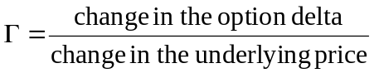
gamma is the second partial derivative of the premium with respect to the underlying price
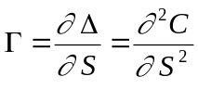
option gamma is used for the second-order approximation of the change in the option premium
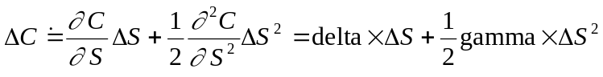
option gamma is very small for deep in-the-money and deep out-of-the-money options but changes rapidly for at-the-money options
option gamma is always positive for long option positions (both calls and puts) and negative for short option positions

gamma-hedging is a strategy that aims to create a gamma-neutral portfolio in which the already delta-hedged portfolio is not affected by changes in the underlying price
the technique of gamma-hedging requires using an addition hedging option

gamma-hedged portfolio
… value of gamma-hedged portfolio
… number of written call options
… number of shares that make the portfolio delta-neutral
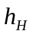… number of hedging options that make the portfolio gamma-neutral (inclusion of these options disturbs delta-neutrality of the original portfolio)
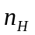…adjustment of the number of shares that restores delta-neutrality of the portfolio (this will not affect the portfolio’s gamma)
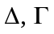… delta and gamma of original options
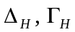 … delta and gamma of a hedging option
delta-neutrality of the original portfolio
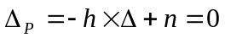
gamma of the gamma-hedged portfolio
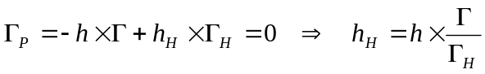
restoration of the portfolio’s delta-neutrality after adding additional options into the portfolio
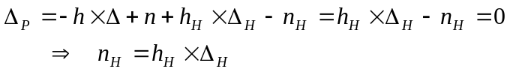

♦
A portfolio of written calls is currently delta-hedged but has a gamma of -60. A particular call option which could be used for gamma-hedging has a delta of 0.5 and a gamma of 0.6.
gamma of the original delta-neutral portfolio
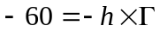
number of additional calls that reduces the portfolio gamma to zero
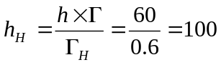 hedging options
adjustment in the number of shares that restores delta-neutrality of gamma-hedged portfolio
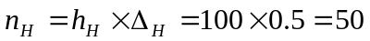shares
♦

c) option theta (time decay of the option) measures how much the option value varies with changes in the time to maturity
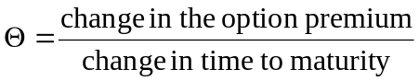
theta is the partial derivative of the option premium with respect to the time to expiry
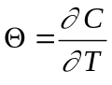
there is no uncertainty about the passage of time so it does not make sense to hedge against this inevitable event

♦
An option is priced at 5p and has 10 days to expiry. The theta of the option is 0.5. Therefore the following day the option price is expected to fall to the value of
p
♦

e) option rho measures how much the option value varies with changes in interest rates
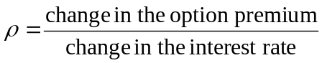
rho is the partial derivative of the option premium with respect to the interest rate
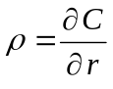

d) option vega (lambda, sigma, epsilon, eta, kappa) measures how much the option value varies with changes in the volatility
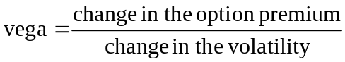
vega is the partial derivative of the option premium with respect to the volatility
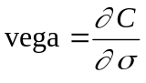

10.4 Put-call parity
put-call parity is an important relationship between European call and put options that have
- the same underlying asset
- the same exercise price X
- the same time to expiry T
similarly to other parities the put-call parity is based on the assumption of perfect financial markets that prevent the occurrence of arbitrage opportunities

derivation:
portfolio A: [European call option] & [an amount of cash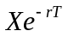]
portfolio B: [European put option] & [one share]

the value of portfolio A at expiration (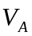)
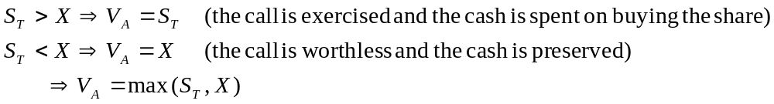
the value of portfolio B at expiration (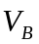)
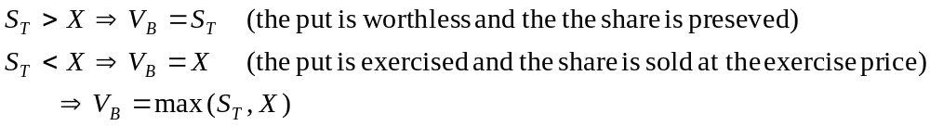
because both portfolios have identical payoff they must have identical values today
put-call parity: 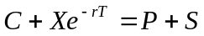

the amount 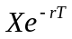 can be interpreted as the present value of the bond whose nominal value is X, time to maturity is T and yield to maturity is the risk-free rate r
the put-call parity can be used for derivation of the following relationships
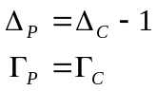

♦
Suppose that following values are observed on the market: S = 31$, X = 30$, r = 10 %, C = 3$, P = 2.25$, T = 3 months.
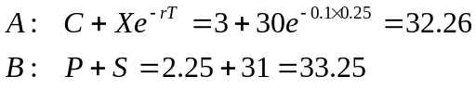
Because the put-call parity does not hold, there are arbitrage opportunities. The correct arbitrage strategy is to buy securities in the underpriced portfolio A and to short securities in the overpriced portfolio B.
strategy: buying the call option, writing the put option and shorting the stock
initial positive cash inflow = 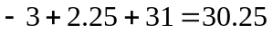
the cash is invested at the risk-free interest rate for 3 months that gives the available amount 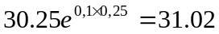

the pay-off from the strategy at expiration
i) 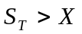⇒ the call will be exercised and the purchased share will be used to close out the short position
net gain = 31.02 – 30 = 1.02
ii) 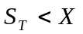⇒ the put will be exercised by the counterparty (there is the obligation to buy the share), the purchased share will be used to close out the short position
net gain = 31.02 – 30 = 1.02
♦
Suppose that the option premiums are following C = 3, P = 1 and that all other variables are unchanged.
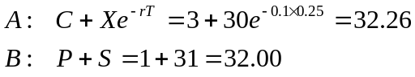
Because the put-call parity does not hold, there are arbitrage opportunities. The correct arbitrage strategy is to sell securities in the overpriced portfolio A and to buy securities in the underpriced portfolio B.
strategy: writing the call option, buying the put option and borrowing the cash for buying the stock
initial borrowing = 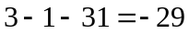
cash needed for the repayment of debt = 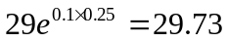

the pay-off from the strategy at expiration
i) ⇒ the call will be exercised by the counterparty (there is the obligation to sell the share), the income will be used for the repayment of debt
net gain = 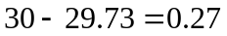
ii) ⇒ the put will be exercised and the sold share will be used to close out the short position
net gain =
♦

Graphical representation of the put-call parity
long bond
long call
X
X
Σ
long put
long stock
Σ

creation of synthetic options
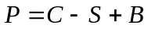 ⇒ the pay-off a long put can be achieved by the combination of long call, short stock and long bond
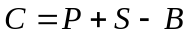⇒ the pay-off a long call can be achieved by the combination of long put, long stock and short bond

XI. TRADING STRATEGIES WITH OPTIONS
trading strategies used with futures can be also used with options
options have some additional advantages
- asymmetric pay-off of options ⇨ unlimited upside potential and great downside protection (deep out-of-the-money option has a delta of almost zero)
- a high degree of leverage ⇨ deep in-the-money options have almost the same profit and loss profile as the underlying security (holding the option is almost as profitable as holding the underlying asset) that is accessible at a low initial investment
- response of the option premium to changes in volatility of an underlying security ⇨ special trading strategies called volatility trading

11.1 Speculative option strategies

a) open position trading involves backing a view on the future direction of the price of an underlying asset (interest rates, exchange rate, share price)
speculator buys options whose premiums are going to rise and sells option whose premiums are going to fall

♦
A speculator believes that the price of ABC shares is going to increase and so he decides to buy ten out-of-the-money June 135 call options on ABC. The current share price is 115p, the option premium is 1p and one option contract is for 1000 shares.
initial cost = number of contracts ×number of shares in one contract × option premium
= 10 × 1000 × 0.01 = 100 £
Ten days later the ABC share is traded at 125p and the June 135 call premium is 5p. The speculator decides to wind up his position.
revenue = 10 contracts × 1000 shares × 0.05£ = 500£
Even though the share price has risen by 8.7 % (= 125/115), the value of out-of-the-money option position has risen by 500 % (= 500/100)!
If the share price had fallen rather than risen, the maximum loss that the speculator would have borne would be 100 £.
♦

b) spread trading involves the simultaneous purchase and sale of related options contracts
types of spreads:
- vertical (cylinder) spread: the same expiry date but different exercise prices
- horizontal (calendar) spread: the same exercise prices but different expiry dates
- diagonal spread: different exercise price and different expiry dates
- butterfly spread: spread of two spreads
motives behind spread trading:
- trading on the basis of a change in fundamental factors determining the size of the spread (i.e. a change in the cost of carry, change in the price of an underlying)
speculator is long in a spread which is expected to widen and short in a spread which is expected to narrow
- trading on the basis of relative mispricing
speculator simultaneously buys underpriced options and sells overpriced options
the trade is usually structured as delta-neutral in order to be protected against overall jumps in option price levels (the proportion of option contract h, called hedge ratio, is given by the proportion of option deltas)
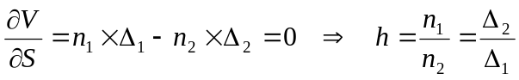
♦
Based on a view about a directional change in stock prices a speculator buys the following calendar put spread on the FTSE 100 index which is currently trading at 3780. The contract has a tick of one index point and the tick value is 10 £.
action: buy September 3700 put at 60
sell June 3700 put at 25
initial cost = 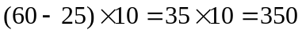£
Ten days later the speculator sells the calendar put spread when the FTSE 100 index is 3720.
action: sell September 3700 put at 90 (the option became less out-of-the-money)
buy June 3700 put at 15 (the option also became less out-of-the-money but was affected by faster time decay)
revenue = 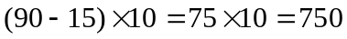£
The speculator earned a profit of 400 £.
♦
Based on the Black-Scholes fair price model a speculator believes that the 125p call options are underpriced in the market and that the 135p call options are overpriced. Suppose that the 125 calls have a delta of 0.8 and the 135 calls have a delta of 0.55.
action: buy 100 of the 125 calls
sell 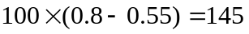of 135 calls
When the price anomaly is corrected the speculator reverses the trade.
♦

c) volatility trading involves buying the options whose underlying’s volatility is expected to rise and selling the options whose underlying’s volatility is going to fall (option premium is positively related to the change in volatility of an underlying security)
types of volatility trading:
- single option trade is exposed to the price risk (it is possible for the price of a call option to fall because the security price has fallen even if there is a large increase in volatility)
- inconsistent implied volatilities
volatility is the attribute of the underlying security so if two different options written on the same underlying security give rise to different implied volatilities then at least one of them is mispriced and the speculator can execute a trade based on the belief that the relative misvaluation will be corrected
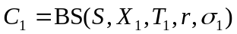, 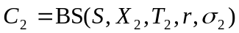
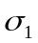> 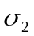⇒ the first option is probably overvalued because its implied volatility is too high and the second option is probably undervalued because its implied volatility is too low
- buying or selling those combinations of options whose profit and loss profile shows a profit irrespective of the direction of the underlying’s price change
straddle is a combination of call and put options with the same exercise price
strangle is a combination of call and put options with different exercise prices
straddles and strangles are usually structured as delta neutral in order to protect the open position against overall shifts in the price level of an underlying security

♦
A speculator believes that the volatility of ABC shares is going to increase and so he decides to buy a delta-neutral strangle to protect against adverse price movements in the underlying security. Each option contract involved is for 1000 shares.
Day1: price of ABC = 115p
price of June 125 call = 3p, delta = 0.50
price of June 105 put = 6p, delta = -0.25
ratio of 105 puts to 125 calls = 0.50/0.25 = 2
action: buying delta neutral strangle = buying one call option and two put options
cost = (1 call×1000shares×0.03£) + (2 puts×1000shares×0.06£) = 150£

Day 15: price of ABC = 105p
price of June 125 call = 2p
price of June 105 put = 9p
action: reversing the trade = selling one call option and two put options
revenue = (1 call×1000shares×0.02£) + (2 puts×1000shares×0.09£) = 200£
net gain = 50£
Even though the share price has fallen, the puts have gained more than the call has lost and the speculator mad a profit.
♦

11.2 Arbitrage option strategies

d) box arbitrage uses options to create two synthetic securities, one long and one short, at different effective prices

credit box arbitrage means that the initial option position collects an income (plus earned interest) that will more than offset a loss at the expiry date of the options
A… long low exercise price put
B… short low exercise price call
A & B ⇨ synthetic short share with low exercise price (at this price the holder has the right to sell the share)
C… short high exercise price put
D… long high exercise price call
C & D ⇨ synthetic long share (at this price the holder has the right to buy the share)
credit box arbitrage results in a loss equal to the difference in exercise prices

Options credit box arbitrage
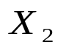
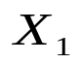
loss at the expiry date
initial income
A
D
C
B
synthetic short share
synthetic long share
0

♦
Suppose that on 1 April the following June option prices are observed on ABC shares when the current price is 115p. The interest rate is 12 % per annum and the position is held for 60 days.
exercise price June calls June puts
105 12 6
115 9 12
125 3 21
Credit box arbitrage trade using 105 and 125 options consists of the following legs:
A… buy 105 put (–6p)
B… sell 105 call (+12p)
C… sell 125 put (+21p)
D… buy 125 call (–3p)
Credit box arbitrage collects an initial income of 24p and leads to a loss of 20p.
net profit at expiry =
♦
debit box arbitrage means that the initial option position incurs a loss (plus financing cost) that will be more than offset by the gain at the expiry date of the options
A… short low exercise price put
B… long low exercise price call
A & B ⇨ synthetic long share with low exercise price (at this price the holder has the right to buy the share)
C… long high exercise price put
D… short high exercise price call
C & D ⇨ synthetic short share with high exercise price (at this price the holder has the right to sell the share)
credit box arbitrage results in a gain equal to the difference in exercise prices

Options debit box arbitrage
initial loss
profit at the expiry date
A
D
C
B
synthetic short share
synthetic long share
0

♦
What is the result of the debit box arbitrage using the data from the previous example?
Debit box arbitrage trade using 105 and 125 options consists of the following legs:
A… sell 105 put (+6p)
B… buy 105 call (–12p)
C… buy 125 put (–21p)
D… sell 125 call (+3p)
Debit box arbitrage shows an initial loss of 24p and gives a guaranteed income of 20p.
net profit at expiry =
♦
e) conversion arbitrage is similar to a box arbitrage but instead of using two synthetic securities constructed from four options it uses one synthetic security constructed from two options and the underlying cash market security itself

the arbitrage profit exists only on the expiration date and it can be destroyed by early exercise
exercise is likely to take place in some circumstances (i.e. in-the-money calls prior to a dividend payment) so the arbitrageur has to trade off the arbitrage profit against the risk of early exercise

11.3 Hedging option strategies
options can be a more flexible alternative to hedging using futures
- when either the amount or the timing of the exposure is not known with certainty
- when the hedger wants to be protected against adverse price movements but would like to benefit from favourable price movements
- when the aim is to hedge the specific risks of individual securities in addition to systemic risks

protective put: a long position in an underlying security is combined with purchasing put option written on the underlying that is equivalent to a synthetic long call
the fund manager is protected (at the cost of the paid premium) if the underlying price falls and keeps the gain if the underlying price rises
the complete profit and loss profile of protective put must take into account the cost of carry
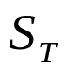
X
at-the-money long put
synthetic long call
long underlying

♦
On 1 April the share ABC that pays an annual dividend of 6 % at the end of each quarter is currently trading at 115 pence. The riskless rate of interest is 10 % and June 115 put has a premium of 10 pence. What is the cost of the protective put strategy?
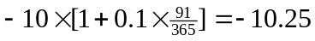 p cost of loan financing the purchase of the put option
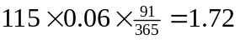 p dividends on ABC on 30 June
The protective put strategy has a cost of 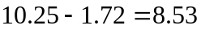 pence.
♦

covered call: a long position in an underlying security is combined with selling call option written on the underlying that is equivalent to synthetic short put
the fund manager is protected from a limited decline in the price of the underlying (because of the earned premium) in exchange of giving up the upside profit potential
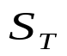
synthetic short put
X
long underlying
at-the-money short call

♦
What is the cost of the covered call strategy if the June call option is currently trading at 12 pence?
p dividends on ABC on 30 June
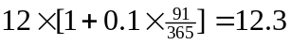 p revenue from writing the call option
The covered call strategy earns an income of 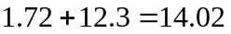 pence that protects the hedger from a fall in the share price.
If the share price drops by more than 14.02 p (bellow the level of 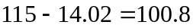), then the hedger will incur a loss. It the share price drops further by 8.53 p (bellow the level of 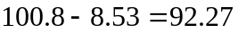), then the covered call strategy leads to larger losses than hedging with the protective put strategy. On the other hand, the protective put gives complete downside protection, whatever the fall in the share price and has better upside potential in the event of share price rising.
♦

conversion arbitrage: a long position in an underlying security is combined with synthetic short position in the underlying created by buying put option and selling call option
the premium earned from the call option offsets, either partly or completely, the premium paid on the put option
the strategy guarantees a fixed profit and loss profile
hedged underlying
X
long underlying
synthetic short underlying
at-the-money long put
at-the-money short call

fixed hedge is a one-off options hedge that is maintained until the exposure is eliminated, at which point the options are either sold or exercised
usually there is one option per one underlying asset share and the full amount of the cash exposure is hedged
determination of a number of option contracts
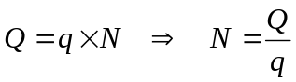
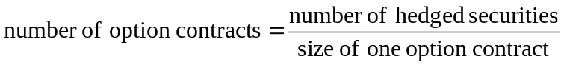
delta neutral (ratio) hedge is designed to establish and preserve a combined cash and options position that is delta-neutral over time
a ratio hedge has to be rebalanced whenever the option delta changes
determination of a number of option contracts (in case of a protective put)
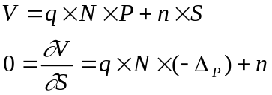
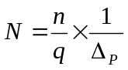
because the delta of an option is always less than unity more options will be required to construct a ratio hedge than a fixed hedge

Comparison of fixed and delta-neutral at-the-money protective puts
a) fixed hedge b) delta-neutral hedge
expiration P/L
short-term P/L
expiration P/L
short-term P/L
X
X
long put
long stock
1/Δ × long put
long stock

properties of the delta-neutral at-the-money protective put:
delta-neutral hedge is more costly than fixed hedge because more puts need to be purchased
in the short-term the delta-neutral hedge shows a short-term profit irrespective of whether the underlying price rises or falls (fixed hedge always incurs a loss when the underlying price falls)
at expiration the underlying price would have to fall or rise enough before the delta-neutral hedge makes a profit (fixed hedge always incurs a loss when the underlying price falls but becomes earlier in profit when the underlying price rises)

a) hedging with individual stock options contracts
rules for hedging:
- if the cash position is adversely affected by falling prices, then buy puts or sell calls
- if the cash position is adversely affected by rising prices, then sell puts or buy calls

b) hedging with stock index options contracts
the aim of hedging with stock index options is to hedge the market (or systemic) risk of a portfolio of shares (contrary to hedging specific risks of individual shares using individual stock options)
specific risks attached to the individual shares in the portfolio remain unhedged by these strategies

portfolio insurance is a set of hedging techniques that aim to provide protection against market decline (in return for paid premium) while preserving the potential for a gain if the market does well (one of them is the strategy of protective put)
… initial value of the stock portfolio insured by protective puts
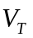… portfolio value at expiry date of the protective puts
 … portfolio beta
… initial stock index value
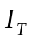… stock index value at expiry date of the protective puts
c … value of one index point
N… number of stock index option contracts
X … exercise price of protective puts

fixed hedge
change in uninsured portfolio value:
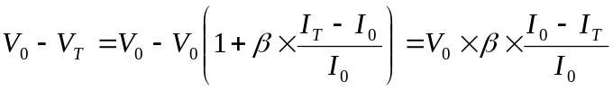
gain in stock index put options:
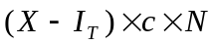
number of option contracts (fixed hedge):
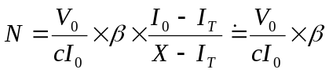 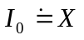(puts are almost at the money)

♦
On 15 July a fund manager has a £ 5 million stock portfolio with beta of 1.15. He intends to hedge the portfolio by buying LIFFE November 1850 put options on the FTSE 100 index that are priced at 51. On 15 July the index closes at 1825 and the fund manager intends employing a fixed hedge.
number of option contracts =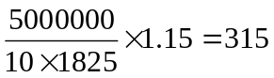
cost of hedge =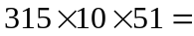160650 £
By the time of 30 November when the options expire the FTSE 100 index has fallen by 20 % to a value of 1460 and the portfolio has fallen by 23 % (in accordance with the portfolio beta,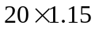).
loss in portfolio value = 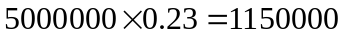£
profit on options = £
The fund manager made an overall profit £.
♦

delta-neutral hedge
insurance against small changes in stock index value
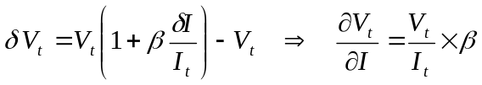
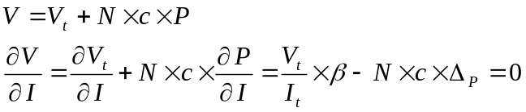
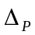 is the delta of protective put option
number of option contracts = 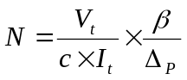

♦
In the previous example the fund manager decides to apply a dynamic delta-neutral hedging strategy. The purchased LIFFE November 1850 put options have a delta of -0.33.
number of option contracts = 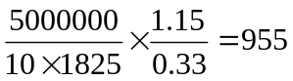
♦

synthetic put option
creating put options synthetically means that at any given time the funds are divided between the stock portfolio on which insurance is required and riskless asset (usually Treasury bonds) so that delta of the overall position is equal to the delta of the required options

delta of the protective put:
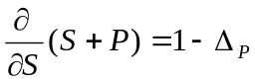
delta of the portfolio whose value is composed of 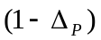% of shares and % of riskless bonds
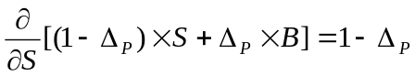
properties of the hedge:
- as the value of the stock increases, delta of the synthetic put declines ⇒ bonds are sold and the position in the stock is increased (the portfolio is composed of shares only when converges to 0)
- as the value of the stock declines, delta of the synthetic put rises ⇒ the bonds are purchased and the position in the stock is decreased (the portfolio is composed of bonds only when converges to 1)
- portfolio insurance may lead to a higher volatility of stock markets (declining stock markets trigger orders to sell shares)
reasons for synthetic put option strategy:
- option markets do not always have the liquidity to absorb the trades with large sums required by portfolio insurance
- required exercise prices and expiry dates are different from those available in exchange traded option markets

♦
A portfolio is worth of $ 90 million. The fund manager wishes to protect its value against market downturn. He considers purchasing a six-month European put option with an exercise price of $ 87 million written on the S&P 500 index. In the end he decides to create the option synthetically. The Black-Scholes formula indicates that the appropriate put option should have a delta of -0.3215 (S = 90 million, X = 87 million, T = 0.5, r = 9 %, σ = 0.25, dividend yield = 3 %). Therefore the fund manager sells 32.15 % of the original portfolio and invests the proceeds into Treasury bonds.
If the value of the portfolio reduces to $88 million and the delta changes to -0.3679, a further 4.64 % (= 0.3679 - 0.3215) of the original portfolio should be sold and invested into Treasury bonds. On the other hand, if the value of the portfolio increases to $92 million and the delta changes to -0.2787, then 4.28 % (= 0.3215 - 0.2787) of the original stock portfolio should be repurchased.
♦

c) hedging using short-term interest rate options
rules for hedging:
- if the cash position will be worsened by higher interest rates, buy interest rate put options or sell interest rate call options
- if the cash position will be worsened by lower interest rates, sell interest rate put options or buy interest rate call options
options on interes rate futures give its hodler the right to open the long postion in a give futures contract at a given exercise price

♦
It is now 1 March and a company intends to borrow £ 2 million for three months on 16 June when the June three-month interest rate futures contract matures. The company is concerned that interest rates will rise between now and June. The following June put options are available:

Exercise  price | Implied borrowing rate | Option  premium | Total cost
88.75 | 11.25 | 0.20 | 250.0
89.00 | 11.00 | 0.50 | 625.0
89.25 | 10.75 | 0.75 | 937.5

total cost = option premium in ticks (20,50,75) × tick value (12.50£)
number of contracts = 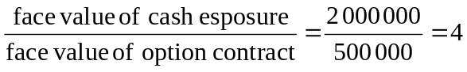

The company’s treasurer faces a trade-off because the more favourable is the locked in borrowing rate, the more expensive is the respective put option:
effective borrowing rate of 88.75 put = 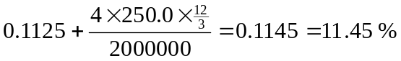
effective borrowing rate of 89.00 put = 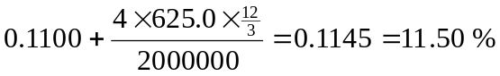
effective borrowing rate of 89.25 put = 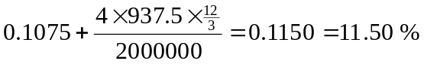

The treasurer would have been better to hedge with the cheaper 88.75 put. This result is reinforced in the case of falling interest rates. All options would have expired worthless but a cheaper option entails a lower loss.
Suppose that on 16 June, when the company borrows the funds and the option and futures contracts expire, the futures price has fallen to 88.00 implying an annual interest rate of 12 %.
profit on futures position = 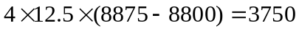£
additional borrowing cost = £
♦
XII. EXOTIC OPTIONS
exotic (non-standard) option is called any option that is not a straightforward (conventional, plain vanilla) option
conventional features: one underlying asset, clear distinction between call and put option, upfront paid option premium, immediate start of the contract and others
long call:
long put:
reasons for financial engineering: meeting specific hedging needs, tax or regulatory considerations, higher profitability, bets on particular movements in market variables and others
major challenge is the determination of the fair price of some exotic options

classification of exotic options
path-dependent options are the options where the payoff and sometimes the actual structure of the option itself depends on the particular path taken by the price of the underlying security over the life of the option
examples: Asian options (average-price, average-strike), barrier options (knock-in, knock-out, rebate, partial window, second chance, floating barrier, forward start barrier), look-back options (floating-strike, fixed-strike, shout, hi-lo)

multiple-asset (correlation) options are the options whose value depends on the relationship between the prices of two or more assets rather than on the price of a single asset
examples: basket option, spread option, product option, rainbow option, dual-strike option, exchange option, quanto option

hybrid options are any other options with non-conventional features
examples: compound options, package options (caped call, floored put, collar), swaption, binary options (cash-or-nothing, asset-or-nothing), chooser option, Boston option, instalment option, pay-later option, Bermudan option, forward-start option

12.1 Financial engineering with the payoff profile
a) Asian (average rate) options
Asian options are options where the payoff depends on the average price of the underlying security during at least some part of the life of the option
average price Asian option – an average price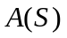replaces single expiry price
average price call: 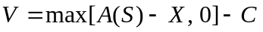
average price put: 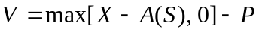
average price options are less expensive due to lower volatility of the average price
average strike Asian option – average pricereplaces an exercise price
average strike call: 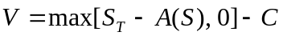
average strike put: 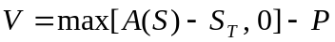
average strike options guarantee that the average price paid for an asset in frequent trading over a period of time is not greater than the final price

Asian options can be defined in terms of arithmetic or geometric averages
averaging formulas can be based on a simple average of market prices (fixed Asian options) or on weighted averages that use some weighting rules (flexible Asian option)
example of the weighting scheme: 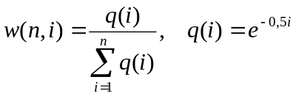

b) package options
these are options which can be interpreted as combinations of other options and possibly a forward contract as well
capped call: limits the upside potential of call option for underlying prices above some threshold level H (equivalent to vertical bull call spread as a combination of a long call with a low exercise price and a short call with a high exercise price)
long capped call: 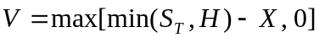
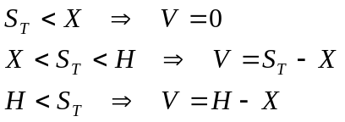

Profit and loss profile of a long capped call
H
H-X
X

floored put: limits the upside potential of put option for underlying prices below some threshold level H (equivalent to vertical bear put spread as a combination of a short put with a low exercise price and a long put with a high exercise price)
long floored put: 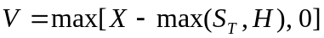
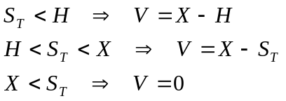
Profit and loss profile of a long floored put
X
X-H
H

collar: payoff from the option is limited by border values 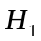and 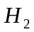
long collar: 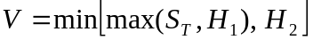, 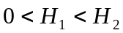
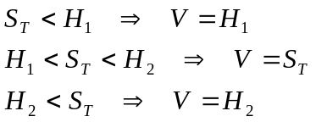
c) binary options
binary options are options with discontinuous payoffs
cash-or-nothing binary option – it pays a fixed amount  if the option ends up in the money, otherwise it pays nothing
cash-or-nothing call:
cash-or-nothing put:
asset-or-nothing binary option – it pays an amount equal to the asset price itself if the option ends up in the money, otherwise it pays nothing
asset-or-nothing call:
asset-or-nothing put:

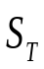
Decomposition of a standard call into binary options
short cash-or-notning call
long asset-or-notning call
X
-X
X

a regular European call (put) option is equivalent to a long position in an asset-or-nothing call (put) and a short position in a cash-or-nothing call (put) with a fixed amount equal to the exercise price

d) look-back options
the payoff depends on the maximum or minimum asset price reached during the life of the option
floating-strike look-back call – pays out the amount by which the final asset price exceeds the minimum asset price achieved during the life of the option
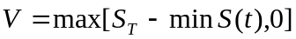
a look-back call is a way that the holder can buy the underlying asset at the lowest price achieved during the life of the option
floating-strike look-back put – pays out the amount by which the maximum asset price achieved during the life of the option exceeds the final asset price
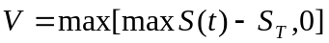
a look-back put is a way that the holder can sell the underlying asset at the highest price achieved during the life of the option
fixed-strike look-back call – pays out the amount by which the highest asset price achieved during the life of the option exceeds a given exercise price
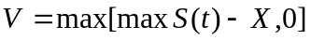
fixed-strike look-back put – pays out the amount by which a given exercise price exceeds the minimum asset price achieved during the life of the option
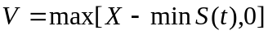
partial look-back options – maximum values of asset prices are restricted on a specific interval during the live of the option or they are applied in some proportion (these modifications make the options cheaper)
shout (one click) option – pays out either the usual payoff from the option or the intrinsic value at the time of the shout (the selection of the shout time is the right of the option’s holder)
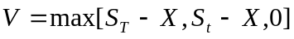, t is the shout (click) time
hi-lo option – pays out the difference between the highest and lowest prices recorded on a security during the life of the option

12.2 Financial engineering with the content of financial instrument
e) barrier options
the payout of barrier options depends on whether the price of the underlying security hits a certain level or barrier during a certain period of time
knock-in barrier option – it comes into existence only when the underlying asset price reaches a barrier
knock-out barrier option – it ceases to exist when the underlying price reaches a certain barrier
down barrier option – the barrier level is bellow the initial asset price
up barrier option – the barrier level is above the initial asset price
8 basic types of barrier options:
down-and-in call, down-and-out call, up-and-in call, up-and-out call
down-and-in put, down-and-out put, up-and-in put, up-and-out put

Possible outcomes for an up-and-in call
B
B
S₀
S₀
T
T
t*
t
t
S
S
barrier
barrier

in the left-hand-side picture the up-and-in call becomes a standard call option at time; the option expires at time T
in the right-hand-side picture the up-and-in call does not become a standard call option during the life of the barrier option

a regular European call option is equivalent to a long position in a knock-out call and a long position in a knock-in call

Decomposition of a standard call into knock-in and knock-out calls
long knock-in call
long knock-out call
X
B
X
B

exotic variants of barrier options
rebate option = the barrier option pays out a predetermined sum (typically the initial premium) if it does not turn into a standard option
partial window option = the option can knock in or knock out for only a part of the option’s life
second chance option = the option knocks in or knocks out only if the barrier is breached for two consecutive days
floating barrier option = the barrier level changes during the life of option
forward start barrier option = the barrier is introduced after some time during the option’s life
Asian barrier option = when the barrier is knocked in the acquired option has features of the Asian option

f) chooser (as-you-like-it) options
the option has the feature that the holder can choose, after a specified period of time, whether the option is a call or a put (with the same exercise price and time to maturity)
let T is maturity of the chooser option and t is the time when the choice is made
put-call parity gives
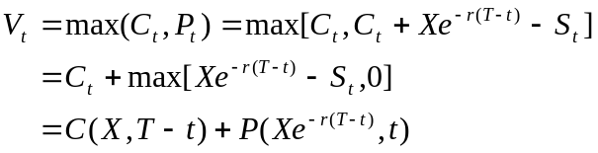
the chooser option is a package consisting of
- a call option (with the exercise price X and time to maturity 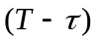
- a put option (with the exercise price 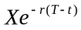 ant time to maturity t)
more complex chooser options can be defined where the call and the put do not have the same exercise price and time to maturity

12.3 Financial engineering with the underlying asset
g) compound options
compound options are options on options
four types of compound option: call on call, call on put, put on call, put on put
compound options have two exercise prices 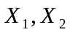 and two expiry dates 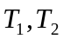
call on call: the holder has the right on the first expiry date  to buy at a first exercise price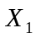 a call option that gives the holder the right to purchase the underlying security at the second exercise price 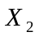 on the second expiry date 
put on put: the holder has the right on the first expiry date to sell at a first exercise price a put option that gives the holder the right to sell the underlying security at the second exercise price on the second expiry date

compound calls will be exercised on the first expiry date only if the value of the option on that day is greater than the first exercise price
compound puts will be exercised on the first expiry date only if the value of the option on that day is lower than the first exercise price

h) multiple asset options
the value of such options depends on the relationship between the prices of two or more assets rather than on the price of a single asset
basket option – the payout depends on the cumulative performance of a portfolio of securities (i.e. individual stocks, stock indices, currency basket)
basket call: 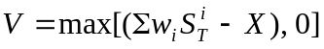
spread option – exercise price is equal to the difference between the prices of two different securities (i.e. difference between raw and refined oil, spread between 3 month sterling LIBOR and 3 month dollar LIBOR)
spread call: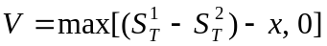 x is a given exercise spread
product option – exercise price is equal to the product of two economic variables (i.e. exports × exchange rate = sales in domestic currency, commodity price × sales = company revenue)
payout of the option: 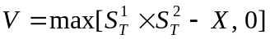
rainbow option – pays out the greatest appreciation from two or more specified markets (i.e. gains on the FTSE 100 or S&P 500 indices)
rainbow call: 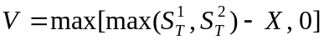
dual-strike option – pays out the greatest intrinsic value from two options written on two different underlying assets (both call and put options can be involved)
payout of the option: 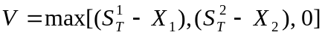
exchange option – gives the right to exchange one asset for another (i.e. exchanging shares of one company for shares of other company in a stock tender offer)
payout of the option: 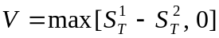
an investor gives up an asset worth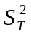 and receives in return an asset worth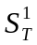
quanto option – pays in one currency on the basis of the movement in the price of a security in another currency at a guaranteed exchange rate (i.e. percentage gain in the Nikkei 225 index payable in US dollars based on a notional amount)
payout of the option: 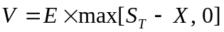 E is the exchange rate

i) swaption
a swaption is an option on a swap
exercising the option delivers the agreed swap from the time of exercise onwards

12.4 Other non-standard option features
Boston option – premium is paid when the option is exercised rather at the beginning of the contract
instalment option – premium increases if the rice of the underlying security passes certain threshold levels
pay-later option – premium is returned if the option ends up out of the money and it is increased if the option ends up in the money
ratchet option – the exercise price improves (from the holder’s point of view) if the price of the underlying security passes certain threshold levels
Bermudan option – early exercise in an American option may be restricted to certain dates
forward-start option – the option contract will start at some time in the future where the exercise price will be also determined (usually in such a way that the option starts in the money)

